Official Program Brossure of the
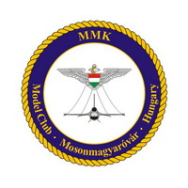
XI. International Modell Exhibition and Competition in Mosonmagyaróvár
14-15th April 2007

Location: West-Hungarian University Mosonmagyaróvár Vár street 2.

Saturday, 14th April 2007

- 8 o’clock to until 13 o’clock: modell registration, handing down them hall of „B” buliding
- 10 o’clock Vehicle Display of the 12nd Antiaircraft Rocketregiment park place of „A” buliding
- 10 o’clock Some traditional Clubs are going to have a show park place of „A” buliding
As: Hetzer, PaK-40, motor side-cars and other vehicles
- 10 o’clock Kite show front of „B” buliding
- 10 o’clock Military films presentation (about program you can inquire at the reception desk) 6th hall of „B” buliding
- 10 o’clock „Budapest in 1945 and nowadays”, Photo exhibition front assembly hall of „B” building
- 10 o’clock „Mosonmagyaróvár and its countryside” Photo exhibition assembly hall of „B” buliding
- 10 o’clock Modell market (selling and buying) „A” buliding
- 13 o’clock Ceremonial opening of the Show: hall of „B” buliding
Nagy István assistant major of Mosonmagyaróvár is going to give us a greeting
and Mosonmagyaróvár’s young talents are going to introduce themself
- 13:15 The announcement of results of the „My favourite car” drawning competition for assembly hall of „B” buliding
Children. The drawnings are going to be on view in the salon of the university
- 14 o’clock Jurying
- 14 o’clock Nagy István assistant major is going to welcome the delegations of the international clubs dinning-room of „B” buliding
- 14 o’clock Free museum visiting
- 14 o’clock Displays of new technologies and new accessories in the modelling world hall of „B” buliding
- 14 o’clock A short journey in Mosonmagyaróvár with equestrian carriage check by information desk
- 15 o’clock Archery, with the help of „Tengri” Archery Club moat
- 15 o’clock A short journey by ship on the Mosoni-Duna, it starts from the parking of building „A” „park place of „A” buliding
- 15 o’clock A cycling tour to Halászi, it takes about 3,11 miles and we guarantee you the bikes „Captain of the Castle” buliding
- 15 o’clock Presentation about the MiG planes. Presenter: Vándor Károly 6th hall of „B” buliding
- 17 o’clock Modell clubs football cup university sport-court
- 17 o’clock Weight-lifter and ping-pong tourneys university sport-court
- 20 o’clock Meeting and conversation with the jury members hall of „B” buliding
Sunday, 15th April 2007

- 9 o’clock Vehicle Display of the 12nd Antiaircraft Rocketregiment park place of „A” buliding
- 9 o’clock Some traditional Clubs are going to have a show park place of „A” buliding
As: Hetzer, PaK-40, motor side-cars and other vehicles
- 9 o’clock Modell market (selling and buying) „A” buliding
- 9 o’clock Kite show front of „B” buliding
- 9 o’clock „Mosonmagyaróvár and its countryside” Photo exhibition assembly hall of „B” buliding
- 9 o’clock A short trip to Hédervár by bus, visiting the castle there. „A” buliding
Starting from the front of the building „A”
- 9 o’clock Traditional clubs are going to make shows from the Romain age up to these days castle outskirt
- 9 o’clock Introduction of „RC Modelling Club” Mosonmagyaróvár lake castle
- 10 o’clock The Kühne brass band’s open-air concert front of „B” buliding
- 10 o’clock Meeting with the leaders of the international clubs board-room of „B” buliding
- 11 o’clock A spectacular modell making show with the best modell makers of Europe hall of „B” buliding
- 12 o’clock Meeting of the youth modell makers, IPMS, and the „B” buliding
leaders of the Fellowship of the Hungarian Modell Makers
- 13 o’clock A cultural introduction of Mosonmagyaróvár’s conservatoire dinning-room of „B” buliding
and several child dancing groups
- 13:30 The official announcement of competition results: dinning-room of „B” buliding
The guests are going to be welcomed by:
- Szabó Miklós major of Mosonmagyaróvár,
The prizes are going to be given by:
- Dr. Baloghné Staár Katalin the Educational, Cultural and
Sport Commitee’s Presidant of Mosonmagyaróvár
- President and Sekretar; Peter Terry and Peter Eley, the founders of IPMS
- brigadier-general Varga László, , the Commander of the 12nd Antiaircraft Rocketregiment
- colonel Sergej Lucisin, Attaché of Ambassadress of the Russian Federacy
- car racer Bartha Attila
- The Hungarian Air Forces’ MiG 29 and Grippen pilot Molnár "Bagira" Gábor
- 15 o’clock End of the competition, handing back of the modells.

We reserve the rights to modificate the program!

Map of the exhibition:
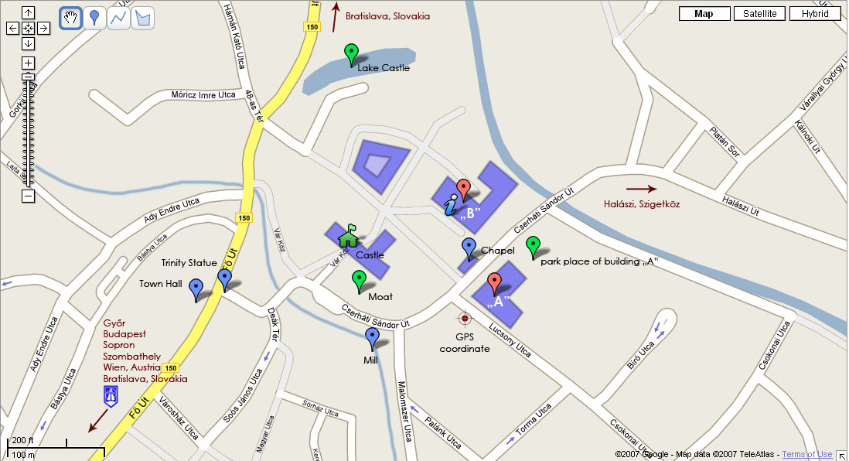

GPS coordinates: N 47.87875' E 17.27643'
(tested with: iGO 2006 & HP iPAQ6915)

