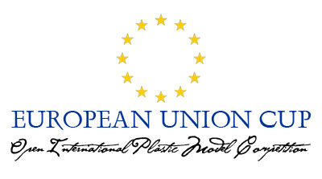

Open International Plastic Model Competition
EUROPEAN UNION CUP

Competition is Declared by :

The Czech Republic
Represented by the Model Club “Apolo” from Kopřivnice

The Slovak Republic
Represented by the Model Club ”Tatranskí Orli“ from Poprad

Hungary
Represented by the Model Club Mosonmagyaróvár from Mosonmagyaróvár

Poland
Represented by the Model Club “IPMS SILESIA“

IDEA AND OBJECTIVE OF THE COMPETITION

It is a new kind of modellers competition which is announced together by number of members of the European Union which are represented by modellers clubs of these countries. The competition stands for the idea of integration and international cooperation also in the area of active leisure time of adults and youth. It comes from the history of many year´s standing experience in organizing big modellers competitions in which modellers and public from many countries have participated. The objective of the new competition is to become a collective international cooperation in organizing international collective events.

STATUT OF THE COMPETITION

The competition is open for everyone without exception of nationality.
The competition will always be guaranteed by the organizing modellers club or clubs representing the announcing country.
The number of announcing countries is not closed and it is possible to add other member countries of EU. Also the change of representing club in each announcing country is possible.
The number of competition categories is not limited either and in next years it should be possible to agree on additional categories.
The evaluation of modells in the competition is provided by the international commission created by experienced modellers from each announcing country. Every country has the same number of votes.

SYMBOLS OF THE EU CUP COMPETITION:

The Main Cups

Each competition category is symbolized by THE MAIN CUP which is 60 cm tall and marked by EU symbol (12 stars in the blue field) and by the name of the category.
The main cups are not given to winner permanently but they are replaced by the National cups which will be given to winners permanently. Names of the winners will be regularly placed on the Main cups.
The Main cups remain the holding of the organizer of the organizer who bought it on his own cost. It has to be arranged that the Main cups must be taken and shown at each national competition.

The National Cups

The height of the NATIONAL CUPS is 30 cm and they will always be marked with EU sign (12 stars in the blue field) and with the national symbol of the organizing country. Other marks are not obligatory.
Buying of these cups is provided by the organizing country and the cups are given permanently to winners.

In each announcing country it is possible to make once a year NATIONAL EU CUP COMPETITION AND TO GIVE THE NATIONAL eu cup WITH THE SIGN OF THE COUNTRY.

It is not necessary that the competition is organized always by the same modellers club.

